**Overview of Project of Data Analysis and Visualization**

Name:Muhammad Fahmi Bin Mohd Zainal

Title: Unlocking Workforce Dynamics: Insights for Enhanced Retention, Compensation Fairness and Diversity

Link of Tableau Public: <https://public.tableau.com/app/profile/muhammad.fahmi.bin.mohd.zainal/vizzes>

Link of Project: <https://public.tableau.com/views/Fahmi_HRAnalyticsStory/Story?:language=en-GB&publish=yes&:display_count=n&:origin=viz_share_link>

Source: Uncleaned Dataset from Kaggle Fictionous Company

Authored By Dr. Carla and Dr. Rich

Links to the source:

<https://www.kaggle.com/datasets/rhuebner/human-resources-data-set>

**Data Cleaning Part (Excel File) in XLXS**

Raw Data

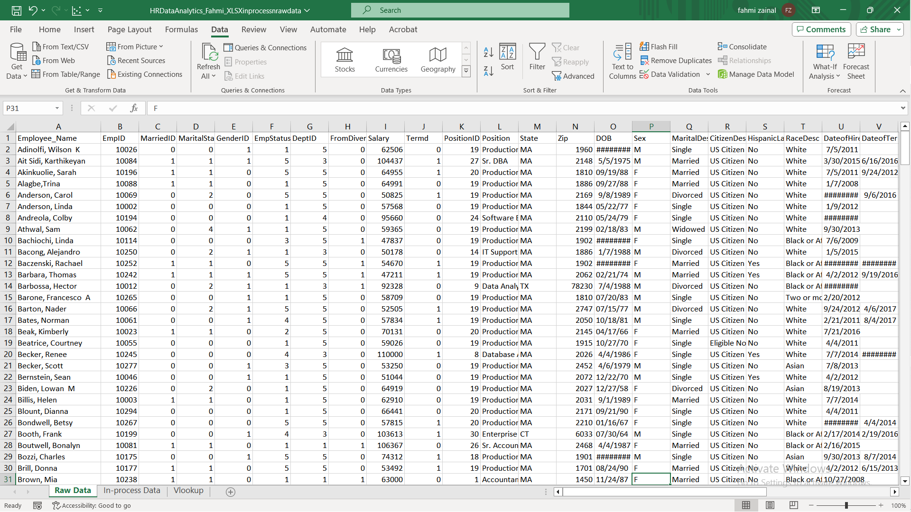

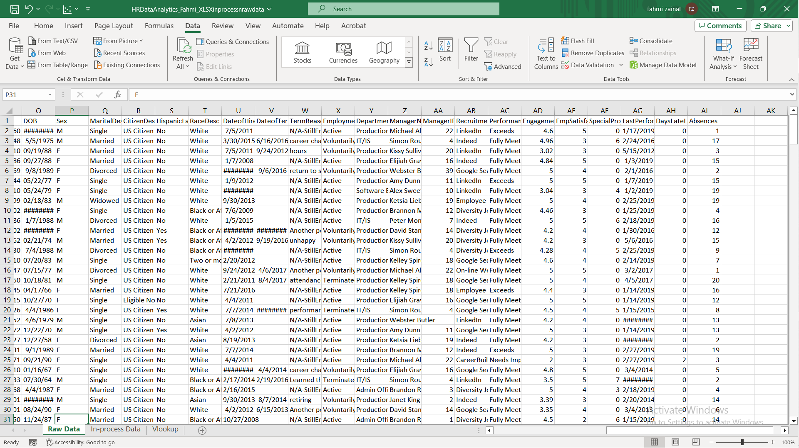

In-Process Data

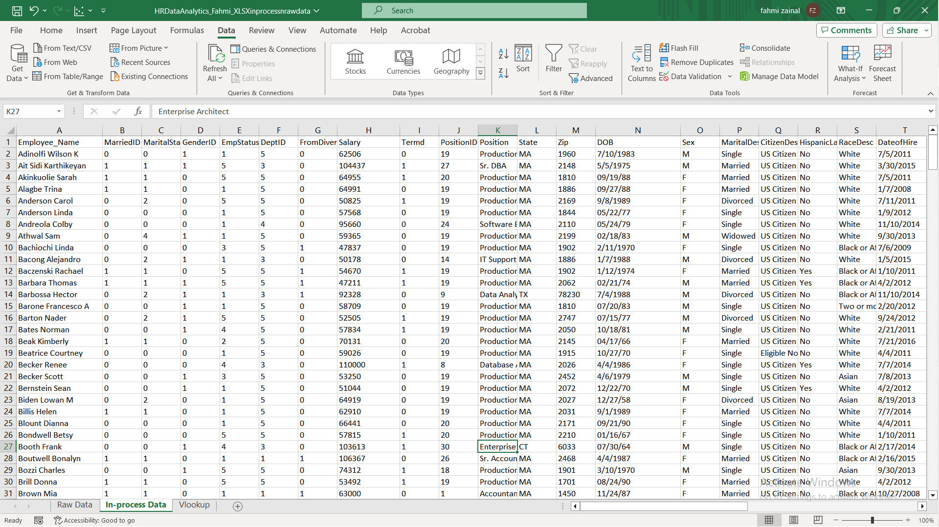

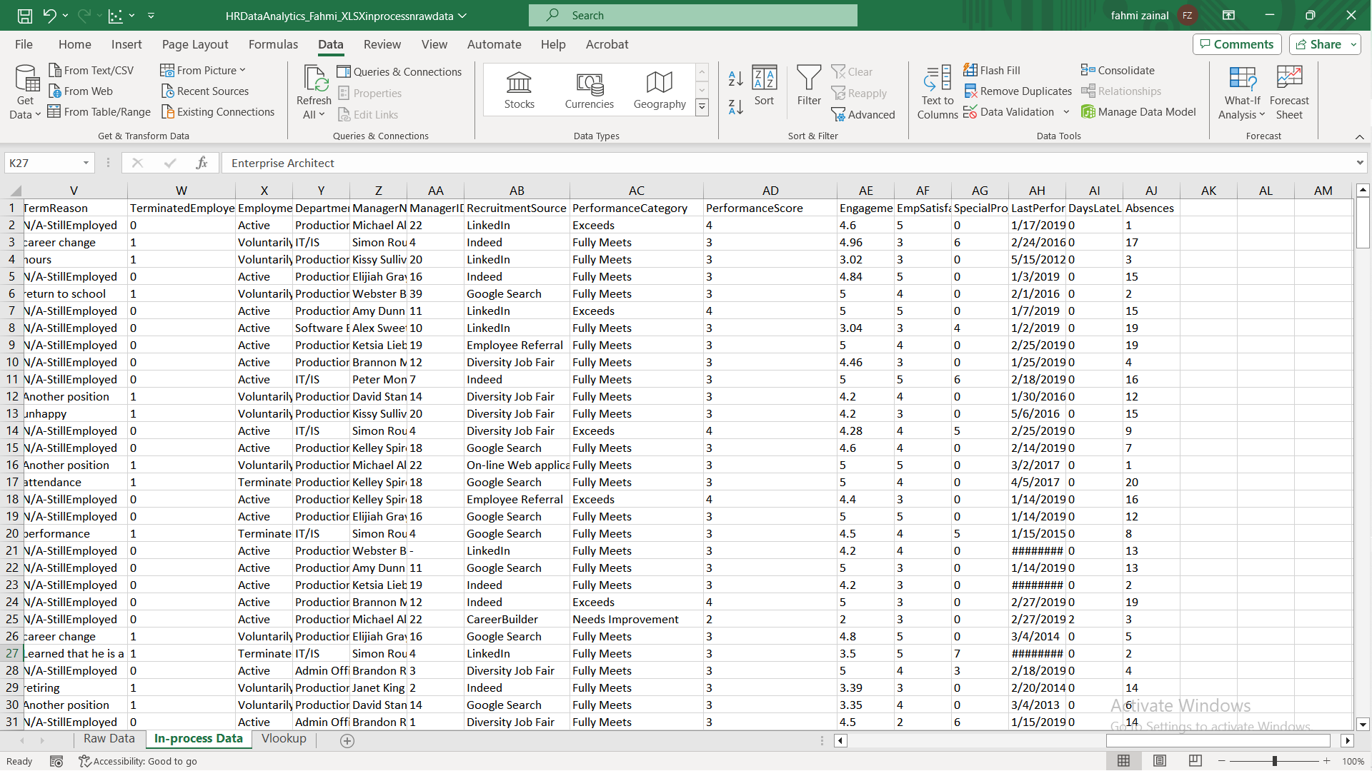

VLOOKUP For Finding The Performance Score

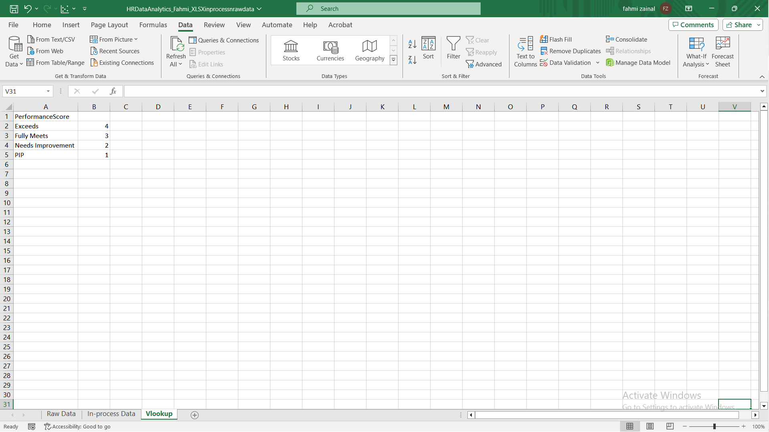

Cleaned Data In CSV File

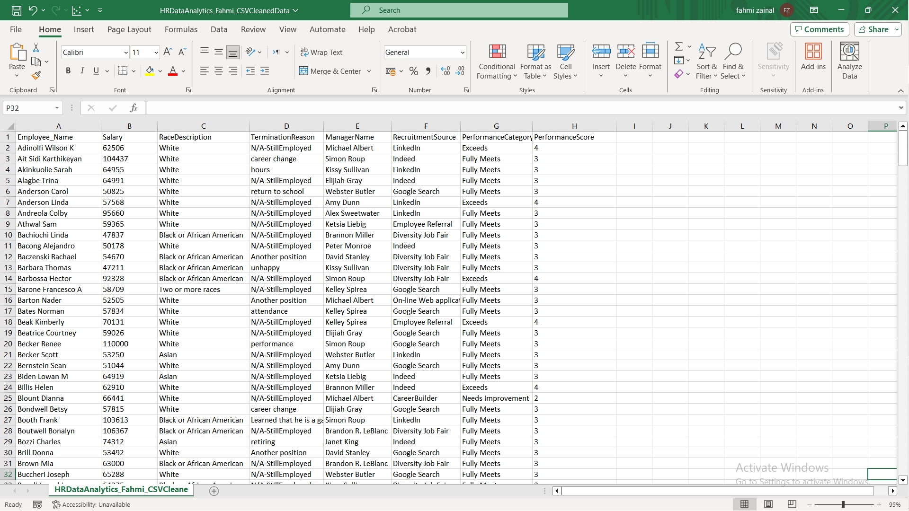

**Ways of Cleaning this data**

**Remove Duplicates**: Eliminated duplicate records to maintain data integrity.

**Clean Employee Names**: Used the Text to Column to remove the comma part from employee names.

**Trim Function**: Applied the TRIM function, =TRIM(selected cell) to remove leading and trailing spaces in data.

**Categorize Performance Score**: Utilized VLOOKUP to categorize performance scores, which can help in analysis In which in Performance Category , with 1,2,3,4 with 4 being the best. so the it is started with performance improve plan (PIP), Needs Improvement, fully meet and Exceed . (based on research studies)

=VLOOKUP(AC2,Vlookup!$A$2:$B$5,2,FALSE)

**Then,Apply Fill Handle**

**Fill NULL Values**: Replaced NULL or missing values with a placeholder, in this case, "(-)."

**Check for the Column to Column Format:** Ensured that is shows the right format of what we want ,whether it is numerical or non-numerical

**Save the Cleaned Sheet in a new file AND Remove unnecessary column:** It will ease us to find the column we wanted to analyse when doing visualization in Tableau

**Save the file it as CSV:**This ensured that the files can be read when we insert in format of TEXT inside the Tableau.

Cleaned Data In CSV File

**Data Analysis and Visualization In Tableau**

From Visual 1 to Visual 6

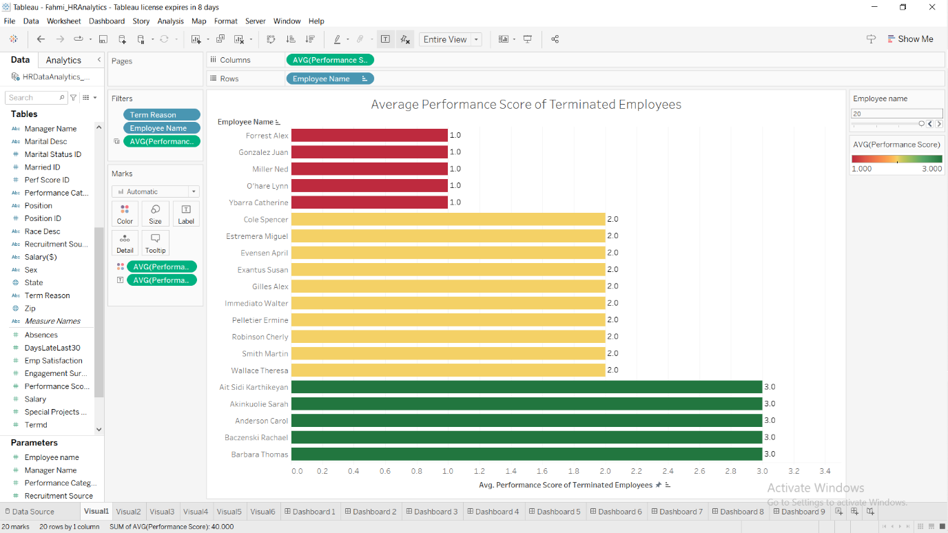

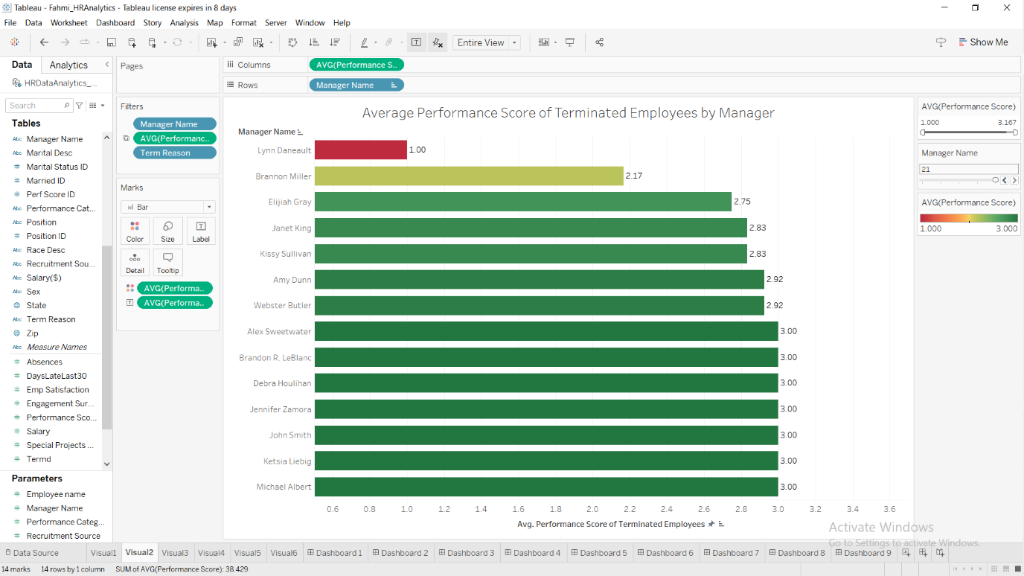

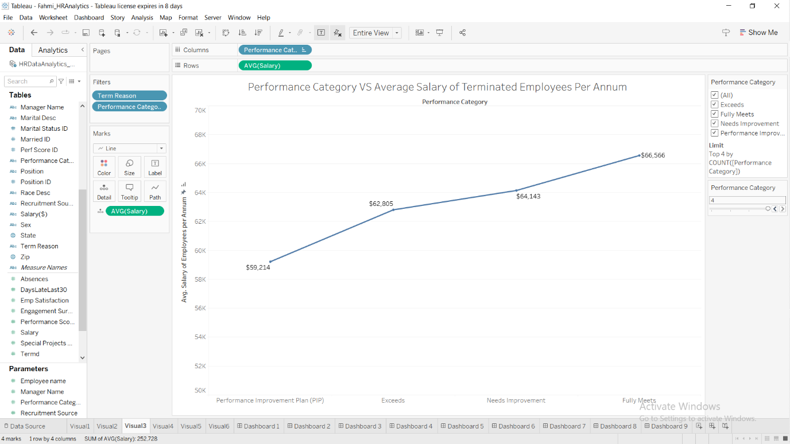

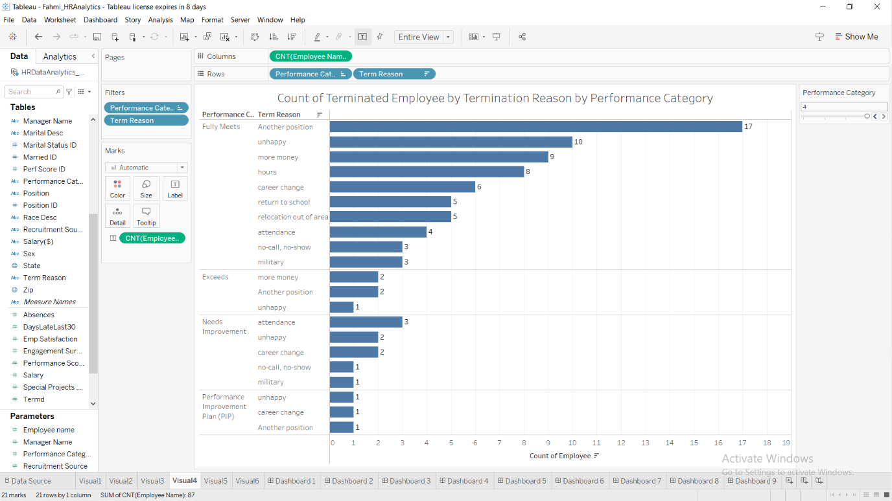

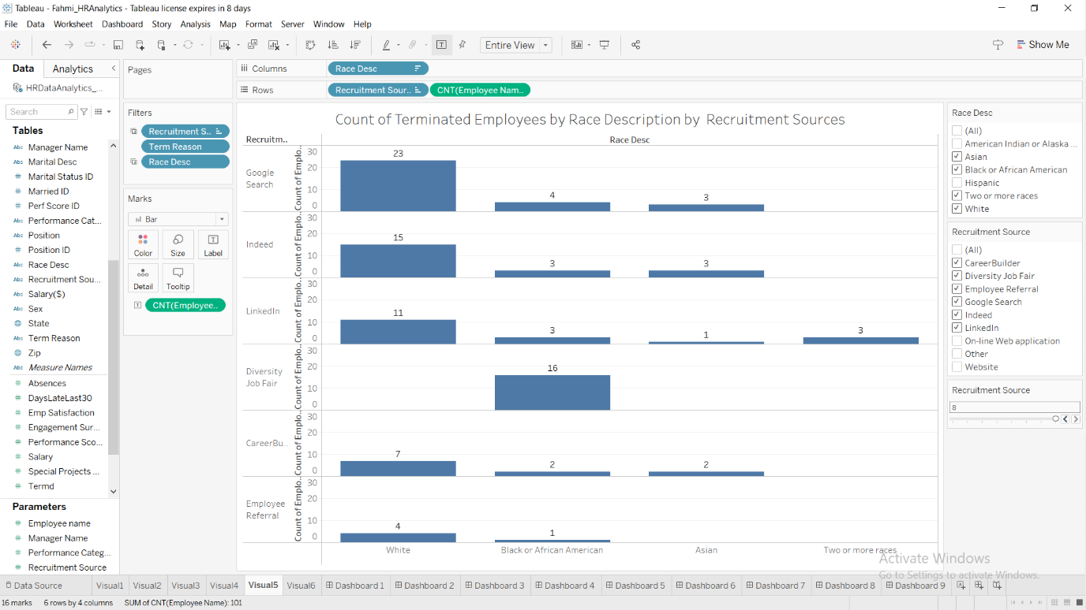

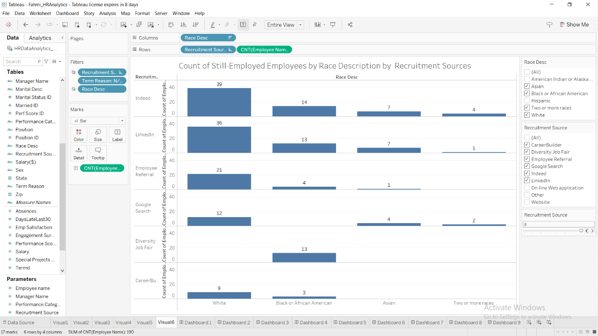

**Dashboard Presentation**

Dashboard 1-9 (Note Dashboard 5 got two screenshot because I move the slider of average performance score to show that how Manager ,Lyn Daneault who had given the lowest average marks to the employees, affecting several employees name in red and yellow box)

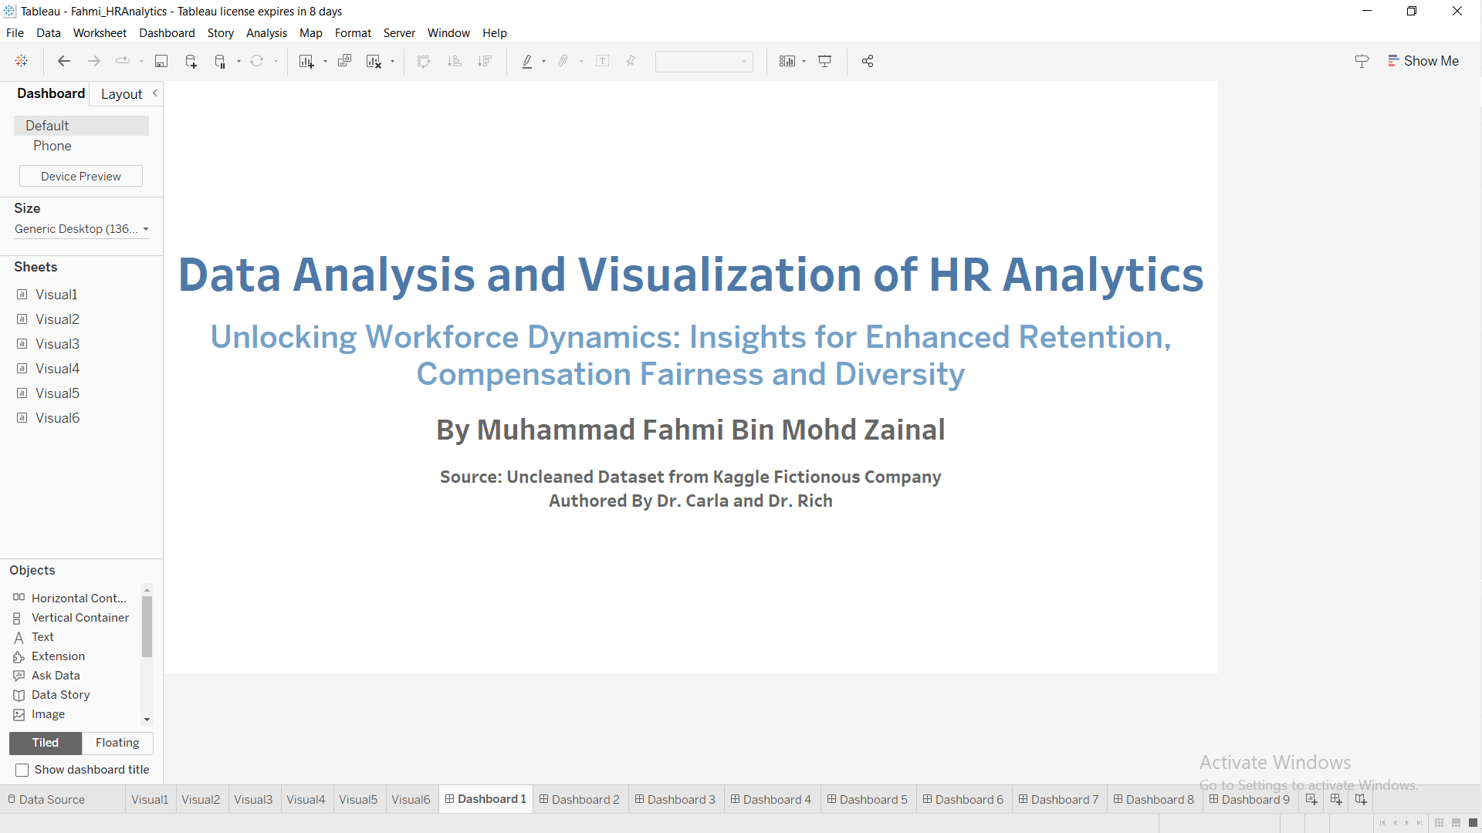

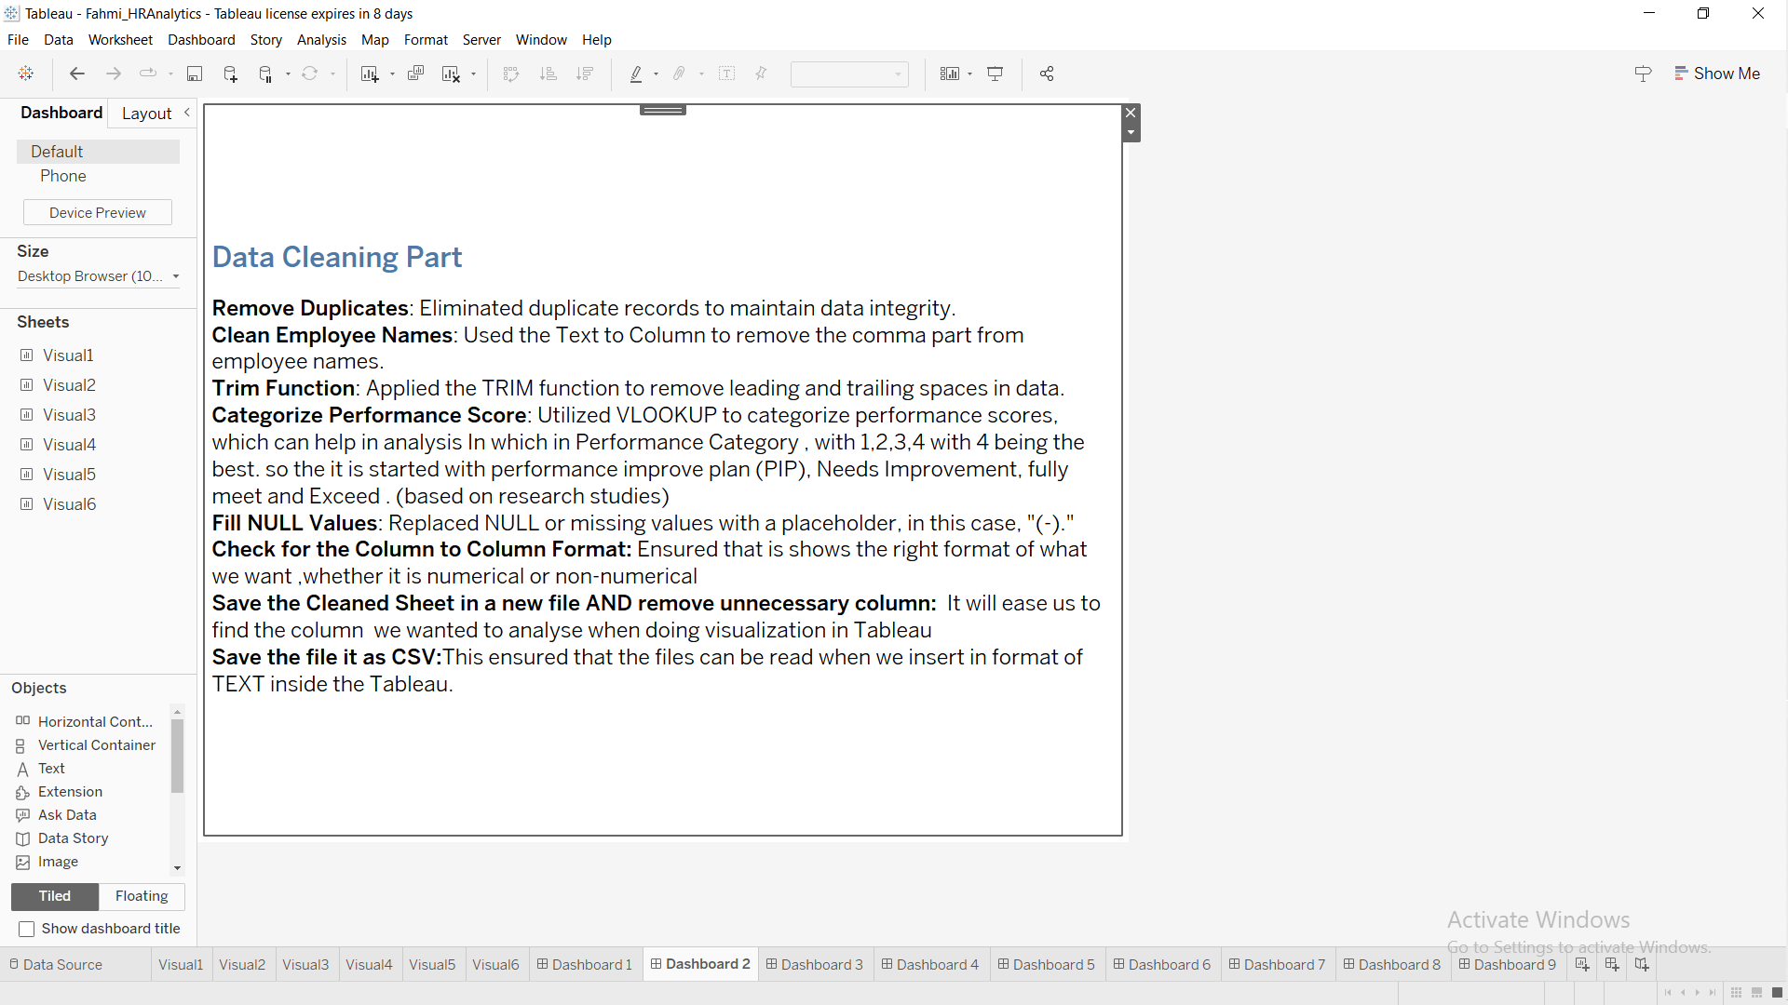

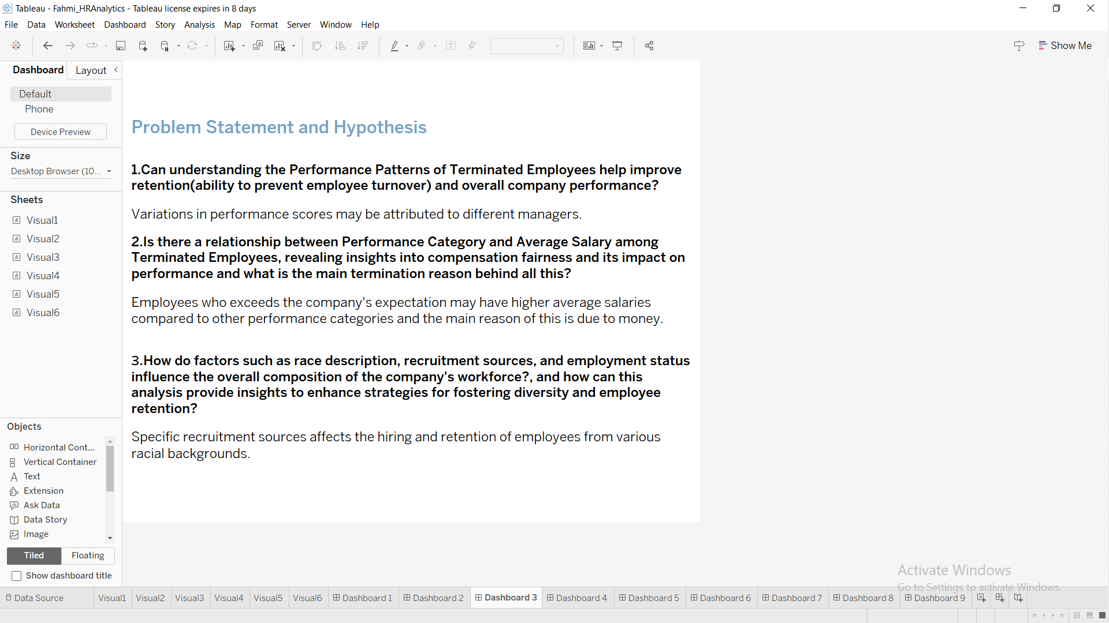

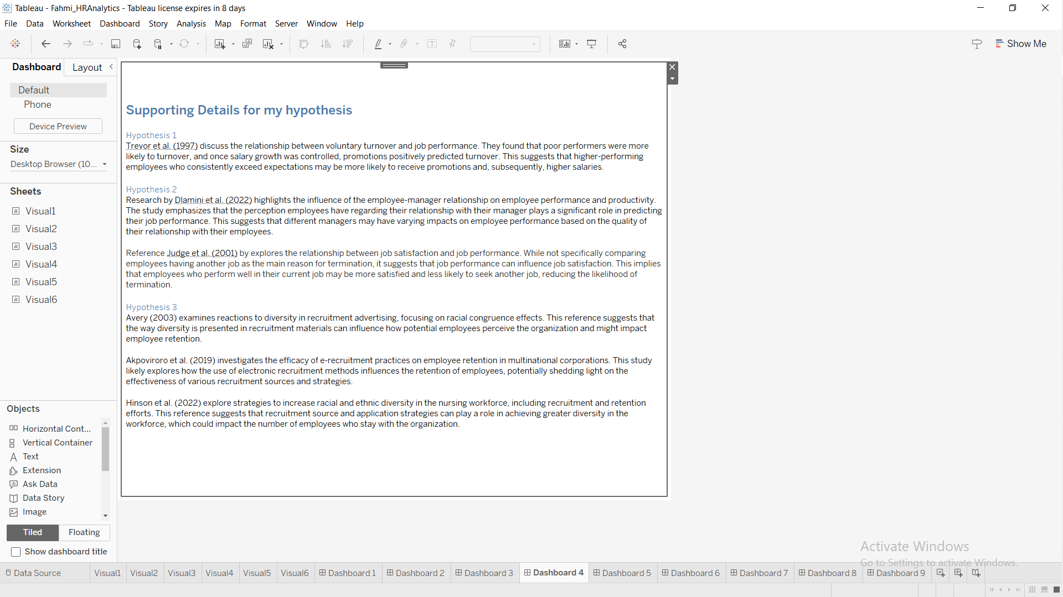

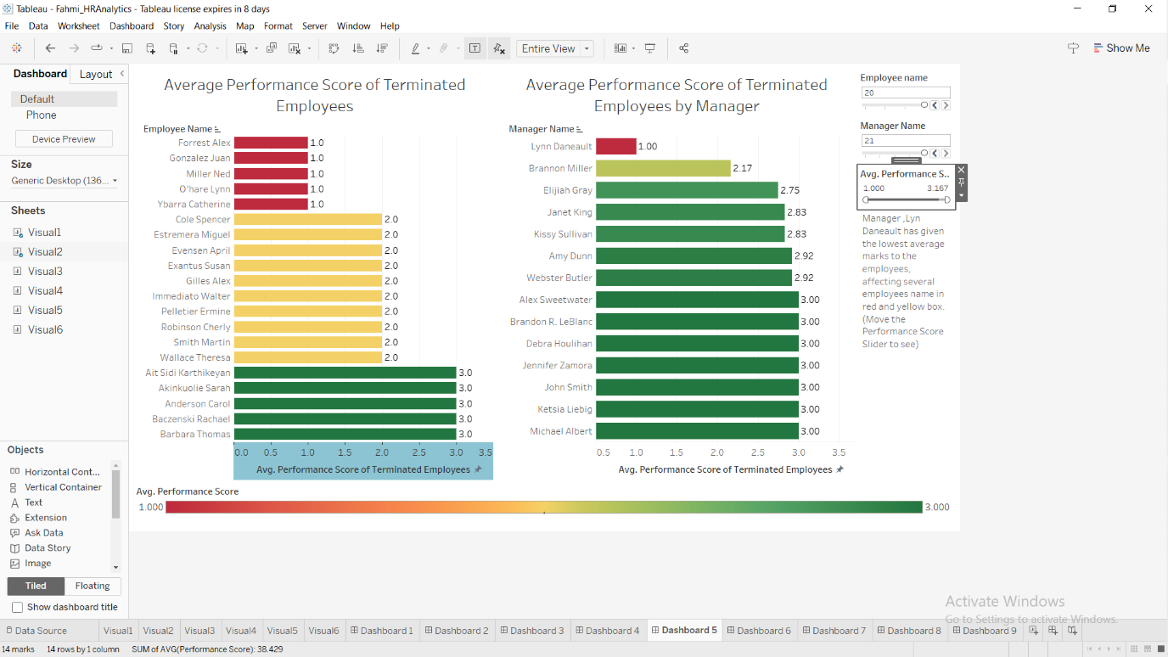

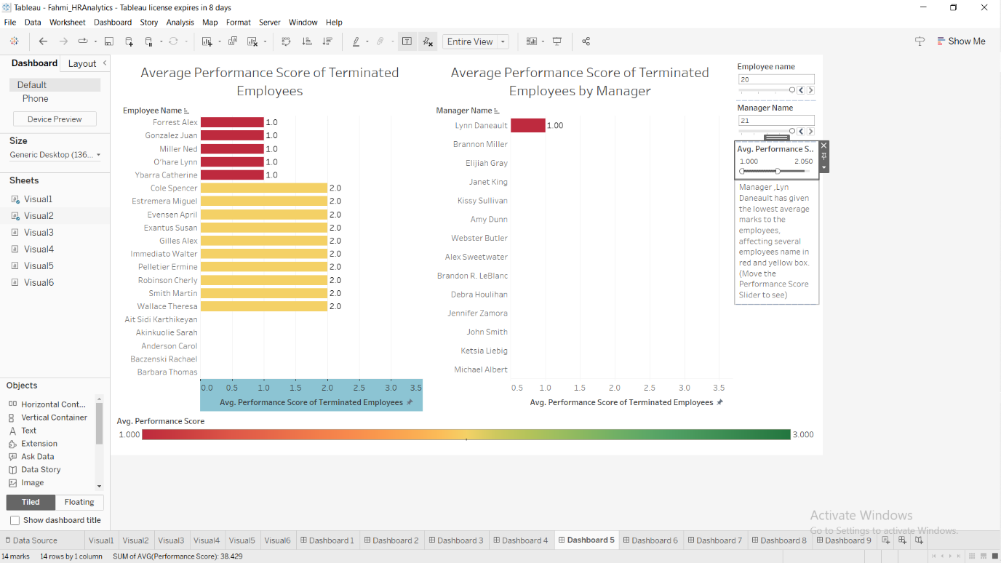

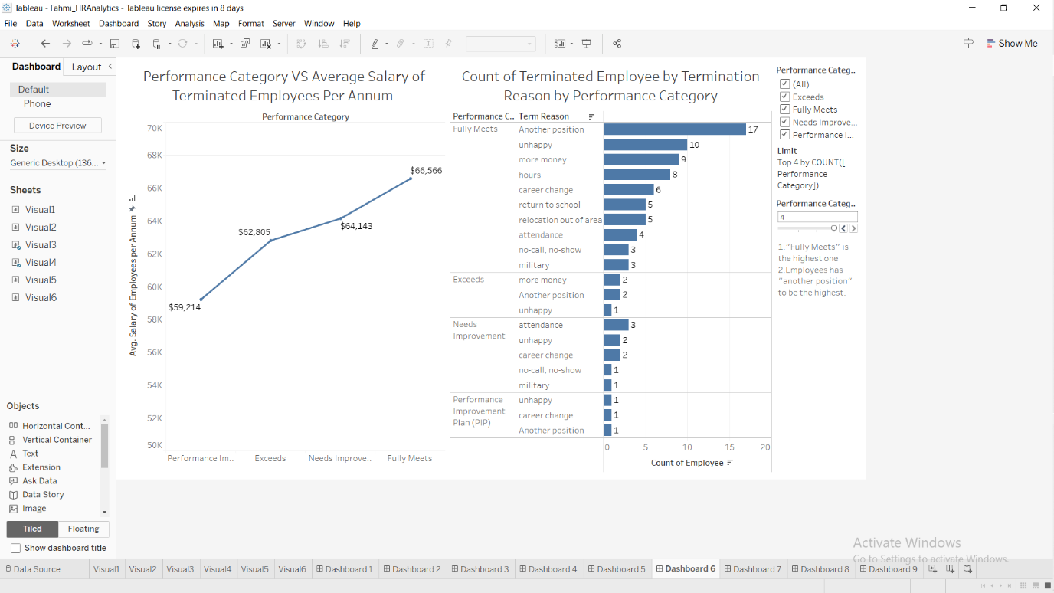

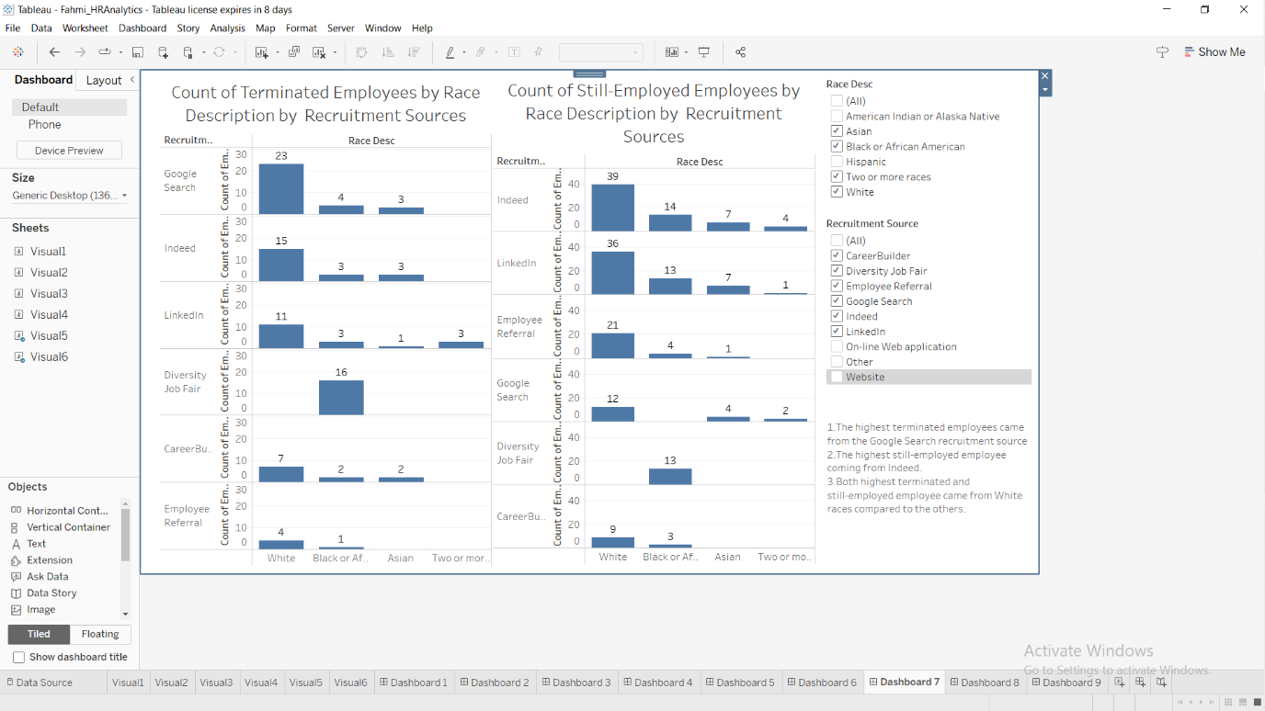

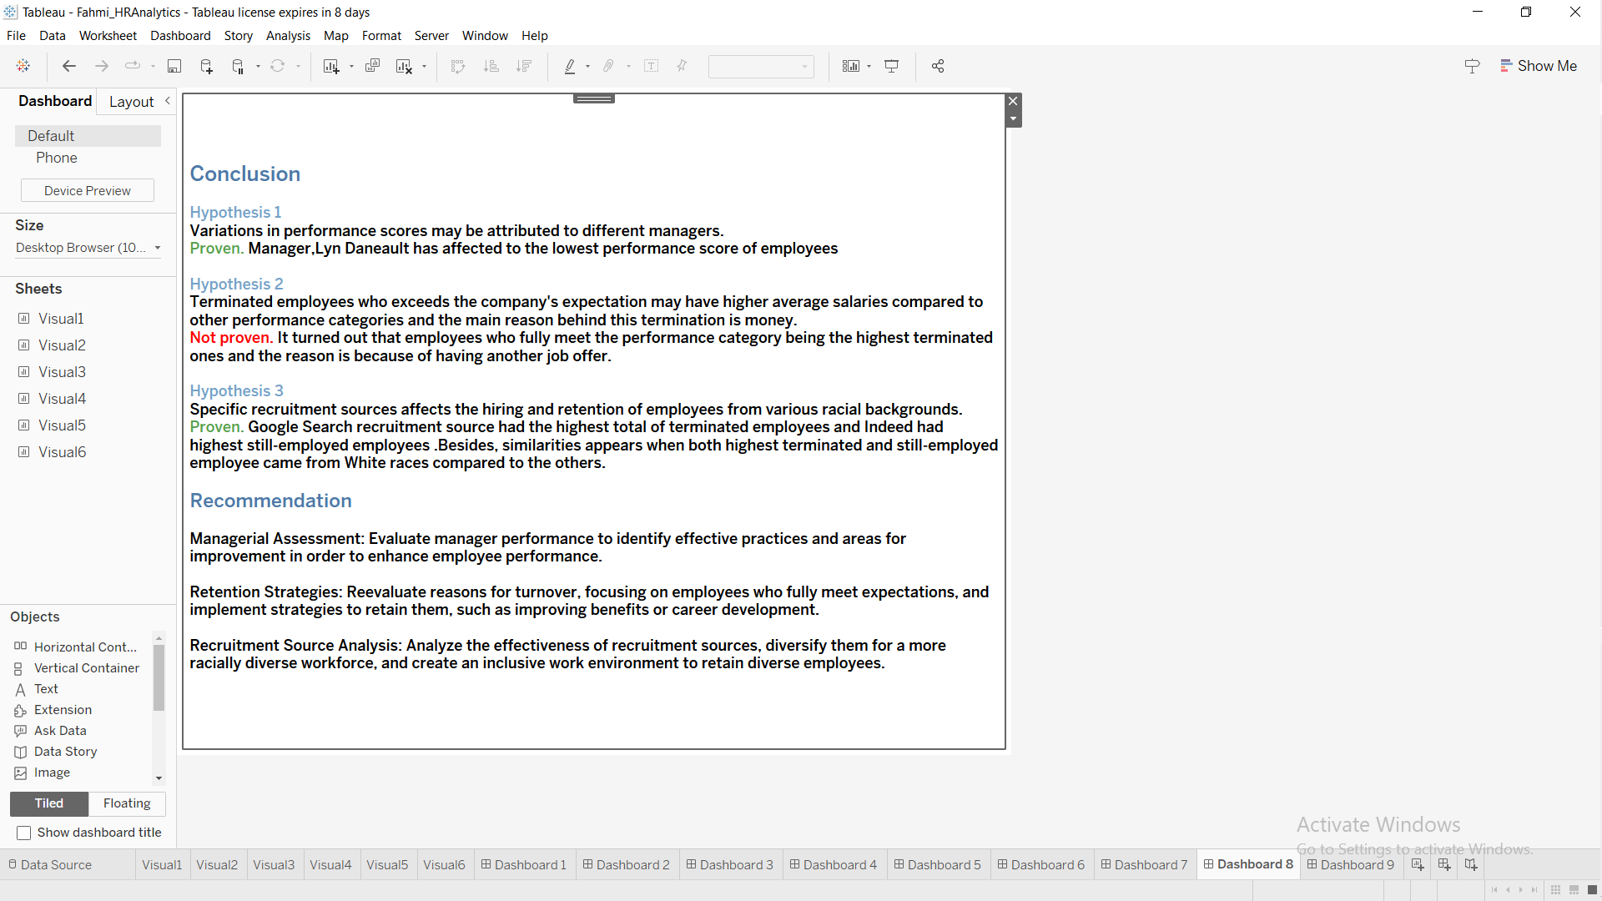

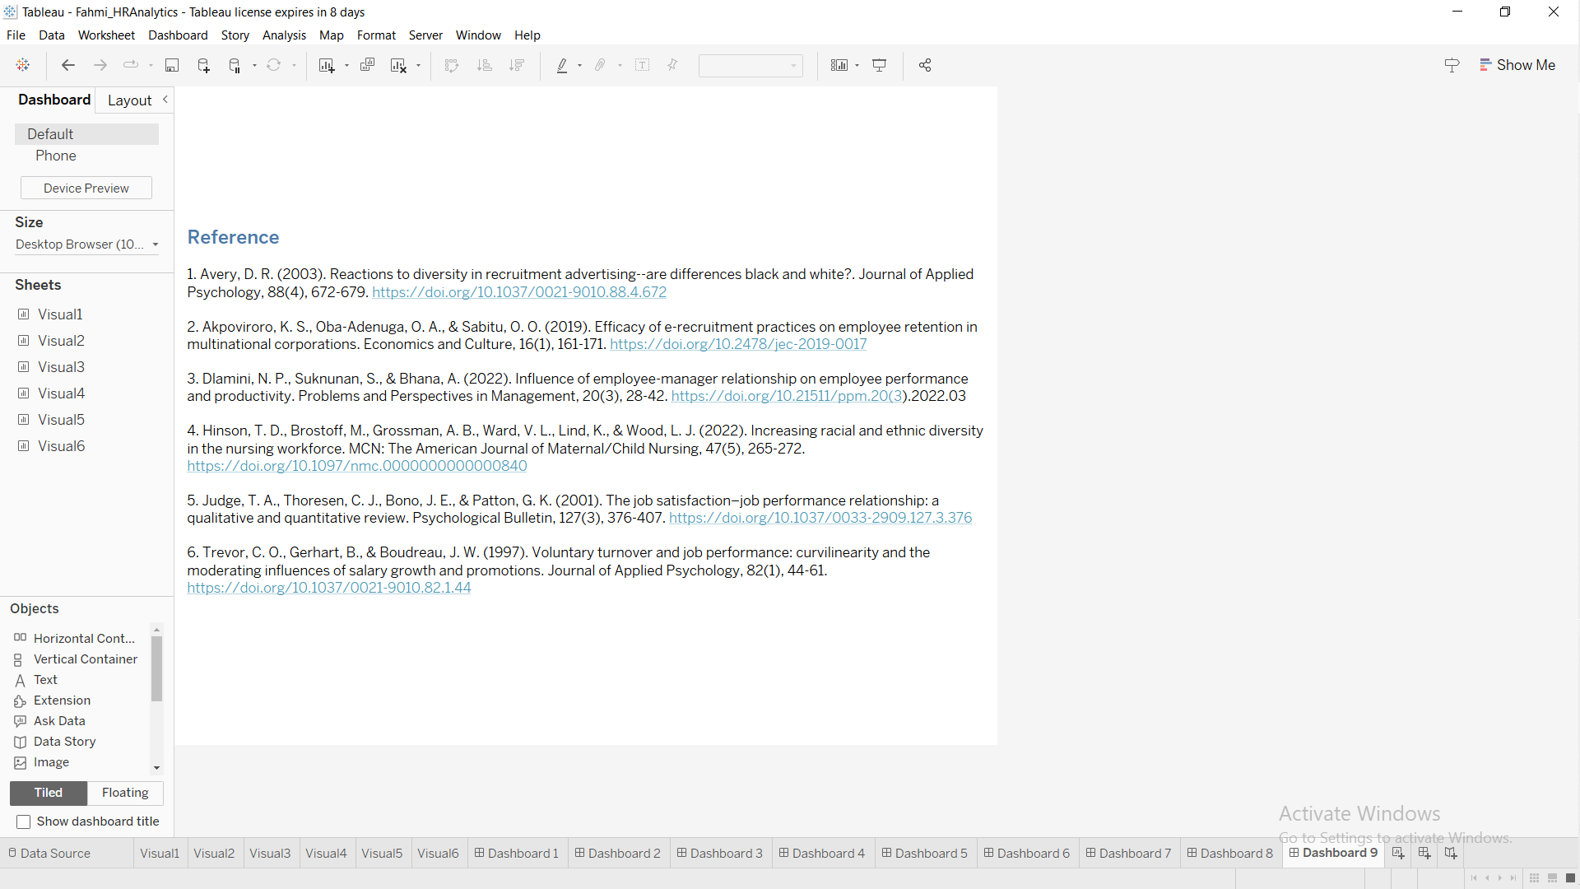

**Guided Story**

<https://public.tableau.com/app/profile/muhammad.fahmi.bin.mohd.zainal/viz/Fahmi_HRAnalyticsStory/Story>

